Core Highways Release Notes v4.0.4.6

Contents
Contents 2
1 Document Control 3
1.1 Author 3
1.2 Document Summary 3
1.3 Document History 3
1.4 Reference documents 3
1.5 Distribution 3
1.6 Quality Assurance 3
2 Introduction 4
3 New Functionality 5
3.1 Key Metadata Changes 5
3.2 Subordinate user metadata 6
3.3 Support for date-tracked datum (join) views 7
3.4 Metadata Checking. 7
3.5 Performance Changes 13
3.6 Other Changes 13
4 Log No. Summary 14
4.1 Customer Raised Issues 14

- Document Control
  - Author
Rob Coupe, Technical Architect

  - Document Summary
This document provides a description of the changes in this release and information about how these changes may impact on an Exor installation.

  - Document History

Document History
Revision | Date | By | Description
1 | 26-Jun-2008 | Exor Development | First Edition

  - Reference documents
None

  - Distribution
Exor Customers, Partners and Staff

  - Quality Assurance
Document Details
File | Prepared By
0000.doc | Rob Coupe
Document Name | Reviewed By
TMA Manager Release Notes v4.0.4.6 | Colin Stewart
Version | Approved for issue by
1.0 | Colin Stewart
Date of Issue | Support Manager
26-Jun-2008 | Graham Anns

- Introduction
This document highlights the key changes to the exor Core Highways database following the release of Core Highways v4.0.4.6. It is specifically targeted at spatial systems users and system administrators of the exor systems. Changes in the core database functionality have the potential to have wide impact across all exor applications and it is important that these changes are understood. However, many of the functions of exor Core Highways are extremely technical in nature and this document is aimed at those with some degree of technical knowledge and not at end users.

It is not intended to be a full system description but a guide to indicate what changes have been made, why they have been made and the potential failings if this upgrade is not applied.

This release is co-ordinated to coincide with releases of UK Street Gazetteer Manager and TMA. However, it should be noted that some important issues are addressed in this interim release and it should be applied to all current systems that are at release 4.0.4.0 onwards.

After reading through this document, should you have any need for training or consultancy then please contact your exor account manager. If these changes are considered important for your current release and this is incompatible with 4.0.4 (for example 4.0.2.2) then please contact exor support.

This patch is intended to be used in conjunction with Spatial Manager SM 4.0.4.6005

- New Functionality
This Chapter describes the main areas of functionality that have been changed in this release.

- Themes metadata changes
- Subordinate user metadata changes
- Support for date-tracked datum (join) views.
- Metadata checking.
- Performance improvements.
- Other changes

The primary purpose of this release has been to make corrections to the core and spatial server systems in the areas of date-tracking datum spatial layers and in the support of subordinate users.

A list of the logs that are known to be cleared by these changes is given in the Log No Summary chapter.

  - Key Metadata Changes
NM_BASE_THEMES and NM_NW_THEMES metadata

Changes implemented in recent releases included the construction of a date-tracked view to deliver the spatial representation of base network data (or datum spatial layer). In order that the relationship between datum and dependent asset and group layers, that is those that are dynamically segmented from measures relative to the datum layer, is consistent, it is important that the NM_BASE_THEMES table contains a reference to the actual base table and not the date-tracked view. During recent upgrades, the data within the NM_BASE_THEMES table made reference to the date-tracked view. This situation has been exacerbated on some customer sites by the inclusion of further join-views whereby the datum layer is represented by a join between an attribute only table and a spatial only table. The generation of new layers from the dynamic segmentation relative to the network would then register the correct metadata.

This has had several potential issues. Having modified the metadata to hold the reference to the date-tracked or join view in the NM_BASE_THEMES table, the Spatial Manager product may not have been able to allow the user to locate an asset relative to the network layer. This is due to the display being a date-tracked view whereas the base theme reference may be pointing to the base table. Also, the logic to change the dependent affected shapes when a datum is reshaped would only be performed on those dependent layers that reference the base table. This had the potential of a datum reshape leaving dependent shapes out of sync.

In the case where join views have been added and used in conjunction with earlier releases of Spatial Manager the reshape process could lead to loss of data or constraint violations as datum shapes were reshaped.

The addition of the date-tracked and/or join views also left multiple records in the NM_NW_THEMES table. This table holds the relationship between a spatial representation and the network data that it represents. This table is used to determine how to perform the dynamic segmentation of asset and group layers and hence having multiple records in this table can lead to the construction of multiple representations of the same asset or group.

The upgrade script for Core Highways 4.0.4.6 will ensure that the NM_BASE_THEMES data is correctly referencing the base table theme and not the date-tracked view theme. The changes to the server code will allow the system to be configured with multiple any number of themes to exist to represent a datum layer so date-tracked and/or join views are fully supported.

  - Subordinate user metadata

It has been noted from several logs that in some circumstances the metadata required to allow subordinate users (not the highways data owner) to gain access to spatial data has been left incomplete. This data is in several components.
- Access to Tables and Views
- Oracle metadata
- SDE Metadata

Access to Tables and Views

The subordinate user gains access to spatial tables through the use of views that are privately registered under the subordinate user schema. The use of public synonyms and private synonyms has been seen to cause problems in some areas and views provide the most reliable approach. Also, access through views is gained through the use of theme roles and the allocation of the theme role to a subordinate user. In previous releases, the access to a theme that was based on a view was not correctly administering the access to the underlying objects within the view.

The core Highways 4.0.4.6 provides checking scripts to report occurrences of failure to access the relevant tables and views and any failures can be repaired by touching the theme roles data. This can be achieved either be removing and adding a theme role or by revoking and re-granting a role to a specific user inside the exor modules. Any private synonyms will be replaced by privately owned views thus over-riding any existing public synonyms should they be employed. The changes to the server code will keep the access to tables and views in a manner that is consistent with the roles that have been granted to users and allocated to themes.

Oracle Metadata

In all matters relating to Oracle Spatial, it is fundamental to ensure that the user has access to Oracle metadata in the USER_SDO_GEOM_METADATA view. In previous releases, the server code could leave a subordinate user with the registration allowing access to spatial views but not always the underlying objects within the view. This meant that in some cases, the subordinate user may not have been able to perform spatial queries on the base table data.

The core Highways 4.0.4.6 provides checker scripts to report on any discrepancies in relation to the data in the subordinate users USER_SDO_GEOM_METADATA. Any such discrepancies can be repaired as described above by revoking and re-granting a role from/to a theme or from/to a specific user. The changes within the server packages will maintain the data in a state that is commensurate with the roles allocated to the themes and to the subordinate user.

SDE Metadata

Users of Spatial Manager require extra metadata to be able to access spatial representations of highways objects inside map. The spatial server part of core registers this metadata at the same time as the Oracle metadata. As above, in some cases, the SDE metadata was left in an inconsistent state for some subordinate users and in some case, the SDE registration of views may be in place but that of the underlying objects of the view may not have been present.

The Core Highways 4.0.4.6 provides a checker script that will report on any discrepancies with the SDE metadata. This data will be refreshed as described above. The changes to the server code will maintain the metadata in a state that is commensurate with the roles applied to the themes and to the users as well as the settings that direct SDE metadata to be used.

  - Support for date-tracked datum (join) views
The changes within the themes metadata allow the system to navigate to the base table to perform spatial queries fully utilising the power of Oracle Spatial. This allows exor services consultants to configure date-tracked and join views as required by the customers to improve the quality of the data within their spatial clients. In particular, when date-tracked views are employed spatial edits and dependencies are properly assessed. Also, the information being extracted from any join view will now be available more efficiently due to some performance improvements in the server code. These improvements should affect some queries in Spatial Manager but will have the most dramatic effect inside the web-mapping environment (for example the locator form) when identifying the nearest feature. As mentioned earlier, corrections have been made in the dynamic segmentation so the introduction of date-tracked or join views have no impact on the result set. Spatial Manager will now allow a user to configure a date-tracked or join view for a specific network type and still locate the asset relative to it. In prior releases, the system would force the client Spatial Manager tool to have the base table theme displayed. Using a date-tracked view prevented the location from being successful.

On starting Exor maps, some code executed to establish scale data for the scale bar. With a date-tracked view in place this was taking an inordinate amount of time. This had been made available as a previous patch but has been rolled up into 4.0.4.6.

  - Metadata Checking.

The product is enhanced with new packages to provide listings of errors and warnings in the integrity of the metadata. Some of these warnings have no impact on the operation of the code but form a useful test. Others are critical to the correct functionality of the spatial tools and need to be addressed. There are three check procedures inside two packages. Each caters for one of the three forms of semi-dependent metadata namely the exor Themes data, the Oracle metadata and the SDE metadata. Each report is delivered to a specified location. There are two packages.

- nm3sdo_check
- nm3sde_check.

Nm3sdo_check reports exor Themes checks, and Oracle Spatial metadata.
Nm3sde_check reports on ESRI SDE metadata (where applicable)

Execution of scripts

Each method requires two parameters – pi_location and pi_filename
Pi_location must be a file system directory on the database server
Pi_filename is the name of the report produced and will be deposited in this directory/folder

To execute the check on Oracle (SDO) Metadata use the following command from a suitable interface such as TOAD, SQL Developer or SQL*Plus.

SQL> exec nm3sdo_check.run_sdo_check (‘/home2/download/utl_file’,’<user>_sdo_check.txt’)

The SDO metadata check has an optional Boolean flag to skip a check for unrecognised Geometry types. This can be used to improve the performance of the check.
To skip the Gtype check, pass in TRUE as a 3rd parameter.

SQL> exec nm3sdo_check.run_sdo_check (‘/home2/download/utl_file’,’<user>_sdo_check.txt’, TRUE)

To execute the Esri (SDE) metadata check, use the following command from a suitable interface such as TOAD, SQL Developer or SQL*Plus

SQL> exec nm3sde_check.run_sde_check (‘/home2/download/utl_file’,’<user>_sde_check.txt’)

To execute the Exor theme validation check, use the following command from a suitable interface such as TOAD, SQL Developer or SQL*Plus

SQL> exec nm3sdo_check.run_theme_check (‘/home2/download/utl_file’,’<user>_theme_check.txt’)

List of checks

Theme checker (nm3sdo_check.run_theme_check)

Themes that are not based on SDO layers
Themes that have a NULL Theme table
Themes that have a NULL Feature table
Themes that have an unsuitable PK/FK combination
Themes that reference a non-existent RSE table
Themes that reference a non-existent RSE FK column
Themes that reference a non-existent Label Column
Themes that reference a non-existent PK column
Themes that reference a non-existent Start Chain column
Themes that reference a non-existent End Chain column
Themes that reference a non-existent X coordinate column
Themes that reference a non-existent Y coordinate column
Themes that reference a non-existent feature PK column
Themes that reference a non-existent feature FK column
Themes that reference a non-existent feature shape column
Themes that reference a non-existent start date column
Themes that reference a non-existent end date column
Themes that reference a non-existent base theme
Themes that reference a non-existent snapping themes
Themes that incorrectly snap to network themes
Themes that are immediate update on edit but have no base(s) theme set
Themes that are immediate update on edit but do not reference Network themes
Themes that are immediate update on edit but are View based themes
Themes that have an invalid sequence name defined
Theme sequences that exist but the Themes have been removed
Triggers that have been used with a theme but the theme no longer exists
Incorrectly set Base Themes

SDO checker (nm3sdo_check.run_sdo_check)

Missing USER_SDO_GEOM_METADATA for Highways Owner themes
Missing Spatial Indexes
Missing USER_SDO_GEOM_METADATA for Subordinate users based on Themes accessed via roles
Missing feature views for Subordinate users based on Themes accessed via roles
Unrecognised Geometry Types (Gtypes)

SDE checker (nm3sde_check.run_sde_check)

SDE Layers that are missing ( ** UNRESTRICTED BY ROLE ** ) (only if running as Highways owner)
SDE Layers that are missing
SDE Layers that refer to missing table/views
SDE Layers that refer to missing Themes
SDE Layers that have missing Geometry Column metadata for feature columns
SDE Layers that have missing Column Registry metadata
SDE Layers that have Column Registry metadata for columns that do not exist on the table
SDE Layers that have missing Table Registry metadata
SDE Layers that have RowID Column registered, but the column is missing from the table
SDE Layers that have RowID Column registered, but the column is not the first indexed column (or not indexed at all)
SDE Layers that have incorrect EFlags metadata
SDO Check - Example Output
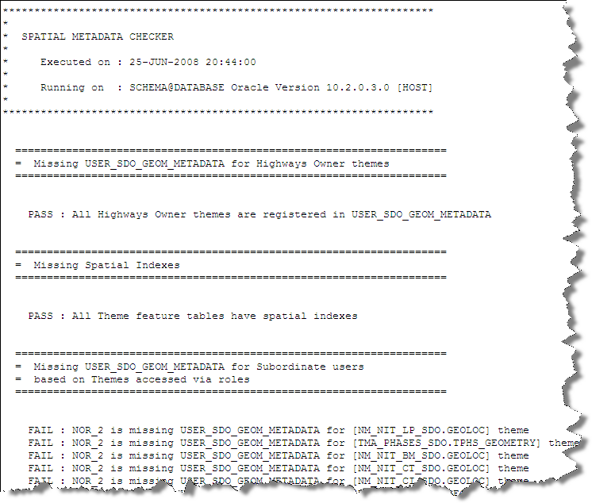
Theme Check – Example Output
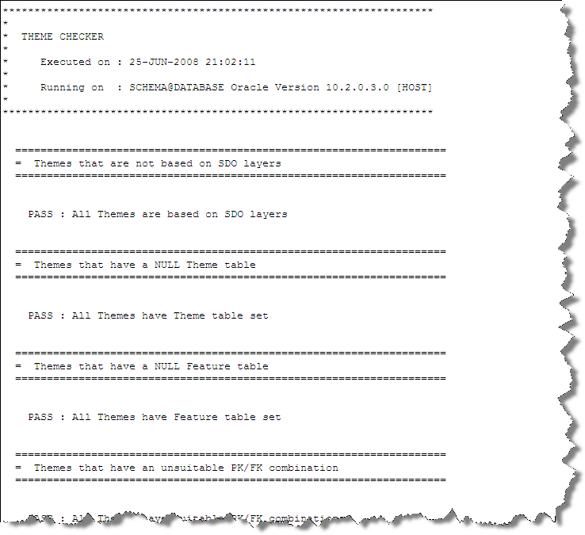
SDE Check – Example Output
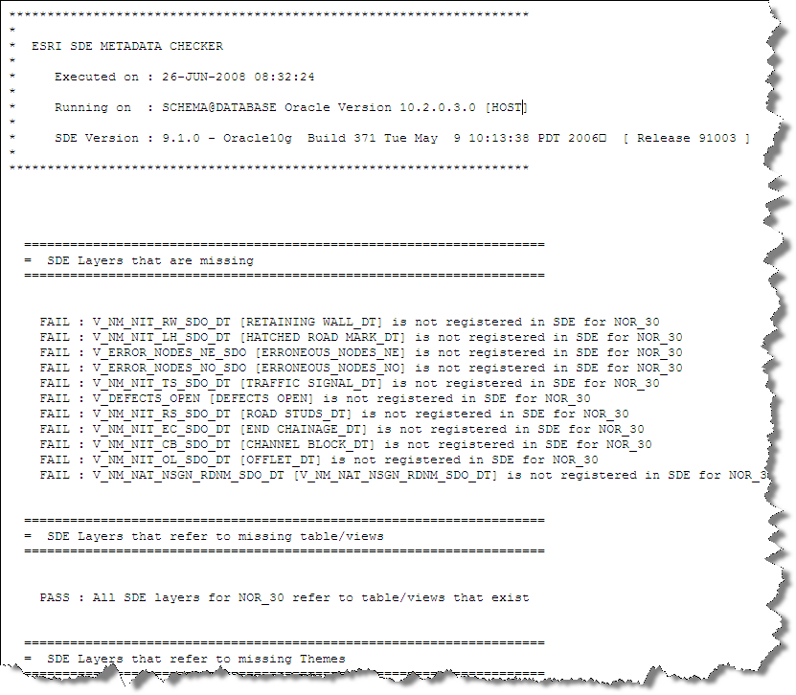
  - Performance Changes
There have been a series of performance enhancements made to the server code many of which are due in part to extensions within the Oracle Optimiser. In particular the changes to the server code will affect spatial searches on date-tracked and join views; this includes snapping (nearest neighbour) searches as well as area or buffer searches. This should result in swifter operation of Exor web maps as well as better performance in spatial operations embedded within other products such as Street Gazetteer Manager when generating placements for associated street data. Also, inside this product the suppression of spatial indexes until further into a process has led to improved spatial performance in the generation of associated street data shapes.

Web map performance has been improved during the starting process although this was shipped as an earlier patch it has been rolled into Core Highways version 4.0.4.6. also rolled into this release is an improvements in the way that private synonyms are handled and this could make a significant difference to customers who make use of private synonyms especially during installation and upgrades.

Some improvements have been made in the execution of the Exor Feature Selection tool inside Spatial Manager. This change may not be significant in cases where the feature is composed of many spatial fragments. Under these circumstances, the client libraries that are outside of Exor control will feed the selected object identifiers into a table and perform queries using poorly composed optimiser hints. The resulting poor performance is outside of exor control.

The performance of the creation of metadata and access to spatial objects has been improved and in some cases this will be noticed and be significant. However, some code relies on externally available APIs and performance may not be sparkling when these are utilised. It is not unreasonable for the maintenance of themes and roles and user access to themes to take several minutes depending on the number of themes and users configured in the system.

  - Other Changes
Previous patches that are also rolled into Core Highways version 4.0.4.6 include the foreign key indexes on the DOCS table. The impact of not having these indexes is significant to users of Maintenance Manager Works Ordering when used in tandem with Public Enquiry Manager. Their inclusion may improve performance generally to some extent whereas in this specific case performance is improved due to significant reduction in locks and the prevention of deadlocks.

The Reclassify function has been improved to avoid cached variables preventing the use of the function more than once in any session. This affects internal processing only and has no impact on the application that is available from within SM or Oracle Forms.

- Log No. Summary
This chapter summarises all Software Bugs and Changes that have been made in this release. These changes are derived from the following sources,

- Customer raised issues

Please note that this is not a full list of the issues that may be cleared as a result of this release. There may be other exor issues that are cleared as a result of the changes to the metadata and these will be cleared during the near future.

  - Customer Raised Issues

Support Call No | Issue
714511 | Create new asset in Spatial manager and asset shape does not appear on the map
714166 | Entering a defect in a web map, snapping to the network fails with “No network found within tolerance”
714410 | Trying to add a new element or reshape in SM the following message appears on SAVE:- Error description: ORA-01776 cannot modify more than one base table through a join view ORA-06512: at HIGHWAYS.NM3SDO, line 4792 ORA-06512 at HIGHWAYS.NM3SDM, line 702 ORA-06512
710193 | Correction to reference-post, correcting the error message: Net-0444: Reference asset types must be point and allowed on the network for the network location.
714216 | Highways owner must display a spatial layer before a subordinate user can gain access. The result “'Layer is not loaded”. This issue may be compounded by the fact that ESRI clients cache the metadata and the user may need to exit and restart to refresh the ESRI cache. The exor themes cache can be refreshed via the right-mouse click on the SM table of contents.
714413 | On reshape of a datum element existing linear asset shapes still follow the old network shape.
713894 | Reshape datum element results in “Error Description: ORA-02292: integrity constraint (HIGHWAYS.NADL_NE_ID_FK) violated -child record found  ORA-06512: at "HIGHWAYS.NM£SDM", line 3356  ORA-06512: at line 1”
713915 | Oracle error when attempting reshape.  ORA-01752: Cannot delete from view without exactly one key-preserved table.
713421 | Failure to locate assets in Spatial Manager
713308 | PK violation on edit. Relates to NSG metadata only.

